Battle of the Neighborhoods

Long Island, New York

July 2020

**Background:** A man and his family is moving to Long Island due to a job transfer. The family would like to live in a single home and not in a busy area. Schools are not a big issue because they do not plan to have children. They would like a home in close proximity to a gym, train, hospitals, and grocery stores, as well as gardens.

**Problem:** The problem is the move must happen very quickly. The family has a real estate agent who has been sending lots of homes with in a 25 mile radius of long island new York and sharing too much information for them to make a decision. The family has a 4 day weekend to search for the homes and want to narrow it down to the best neighborhood to maximize the amount of time they have to look at the homes.

**Data Acquisition:** Thew family wants to use Foursquare.com Data in order to determine the best locations to search Long Island. They will submit a number of questions based on their interests in order to determine the best location to search homes.

**Data Requirements:** The Family wants to compare neighborhoods in the are and has specific requirements.

1. Office location is 150 Old country road, in Hicksville ny.
2. Husband wants to commute less than 5 miles because he likes to ride his bike to work on nice days and a short communte in bad weather.
3. The wife wants to be within walking distance to train for her commute to venues.
4. They want to see locations of venues in the area to understand the business and located compared to homes.
5. The wife would like to shop so a close by mall would be nice.
6. Husband like to work out so a gym near by is a necessity.
7. They like to work on the house and fix it up so a hardware store should be in the neighborhood.
8. They would like a hospital around in the event of a medical emergency.

**Findings:** Foursqare data was used to plot the location of the new office. A search as conducted for the criteria in a 10 mile radius. They extended radius was selected to search foursqueares full database and develop options that might be located between 5 and 10 miles.

1. Venues search: Search found 49 venues within a 10 mile radius.
2. Malls Search: Search found 10 malls in a 10 mile radius.
3. Train search: search found 11 Stations in a 10 mile radius.
4. Gym Search: Search found 29 gyms in 10 mile radius.
5. Hardware search: Search found 26 hardware stores in 10 mile radius.
6. Gardens search: found 2 gardens in 10 mile radius.
7. Hospital search: found 14 hospitals in a 10 mile radius.

**Analysis:** The overlay of the data shows 2 locations that meet the familys criteria. Hicksville, and Westbury. The town of Hicksville is the first option because it has a train station close to work and a lot of venues with hard ware stores. Westbury does not have as many venues and is further from the malls.

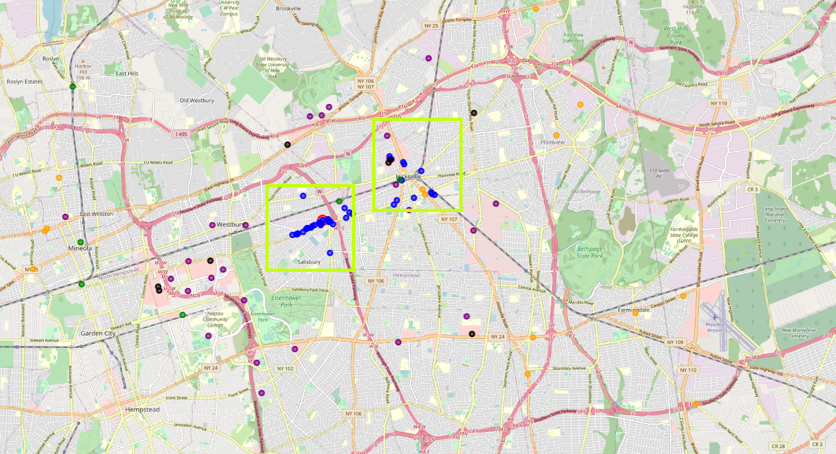

**Summary:** The recommendation for the family is to conecentrate their search on Hicksvill with a secondary option of westbury.